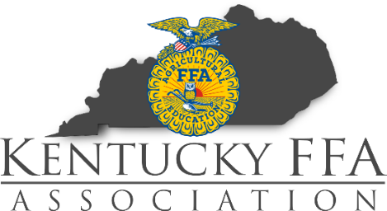

William B. Tolle Leadership Award
This leadership award has been established in honor of Mr. William B. Tolle and his service to the Kentucky State Fair and Kentucky Agriculture. One Kentucky FFA member who:
- Is registered to show, and competes in showing a market livestock animal in the 2022 Kentucky State Fair
- Demonstrates considerable leadership qualities
- Completes and returns this application by including it along with supporting documentation to Kentucky State Fair Entry Department.
  - Kentucky State Fair Entry Dept.
William B. Tolle Award
P.O. Box 37130
Louisville, KY 40233
- Postmarked no later than July 25, 2022.
- Attaches a copy of most recent, official transcript
- Attaches a recent headshot photo
- Attaches one letter of recommendation, written by a non-family member
The winner will receive a one-time $500 award from the Kentucky State Fair Board in honor of Mr. Tolle.
One member of 4-H and one member of FFA will be recognized at the 2022 Kentucky State Fair Championship Drive.

Applicant Information:
Name: ____________________________ School: __________________________________
FFA Chapter: ______________________ Advisor: _______________________ Grade: ____
Mailing Address: ________________________________ Phone #: _____________________
________________________________
Applicant Signature: _____________________________________ Date: ________________
Parent/Guardian Signature: __________________________________ Date: ______________

Involvement: (Additional Pages are Acceptable)
Please tell us about your involvement in FFA and other agricultural youth organizations, community, volunteerism, and other leadership activities. Please list any offices held.

Awards & Employment: (Additional Pages are Acceptable)
Please list all scholastic honors and awards that you have received. Additionally, list your employment history and a brief description of job duties with each.

Essay:
- Attach your response to the essay prompt
- 12 pt. font
- Times New Roman
- 1” margins
- Maximum of 500 words
In your own words, define leadership. What has been the greatest lesson that you have learned about leadership and how do you plan to put that into action in the future?

